Assignment 1

Team 8 : Shyam Prasad V Atri , Parikshit B G , Raghavendra Pai , Anish Sinnha

Q1. Write the system dynamics for the estimated state X_hat in terms of measured output Z. Draw a block diagram representing the observer for the system shown below,check the rank of the observability matrix,find the observer gains(L) using pole placement and compare how X and X_hat evolve over time.Write a programme to plot X and X_hat

X_dot= $(\begin{matrix}-1 & 2 \\ 0 & -2\end{matrix})$ X

Y=[1 -1]X

Solution

A= $\begin{matrix}-1 & 2 \\ 0 & -2\end{matrix}$

C=[1 -1]

To examine Observablity

[C | A*C | A^2*C]

Rank=2

Full Rank so observable

To Determine Observablity gain matrix

function assignment1_040214

a=[-1 2;0 1];

b=[0;1];

d=1;

c=[1 -1]; % rank same for actual and modified

c_modified=[-1 1];

c_actual=[1 -1];

r=[c' a*c' a*a*c' a*a*a*c'];

ran=rank(r)

p=[-1 -1];

ke_actual=acker(a,c_actual',p)

ke_modified=acker(a,c_modified',p)

system_modified=ss(a,b,c_modified,d);

system_actual=ss(a,b,c_actual,d);

s_obs_modified=ss(a-b*ke_modified,b,c_actual,d);

s_obs_actual=ss(a-b*ke_actual,b,c_actual,d);

step(system_modified,'b')

hold on

%step(system_actual,'r')

step(s_obs_modified,'g')

%step(s_obs_actual,'y')

hold off

end

OUTPUT

ke_actual = 0 -2

ke_modified = 0 2

Modified graph

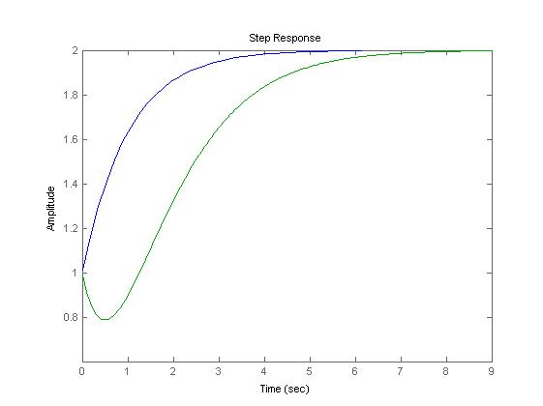

Actual system graph

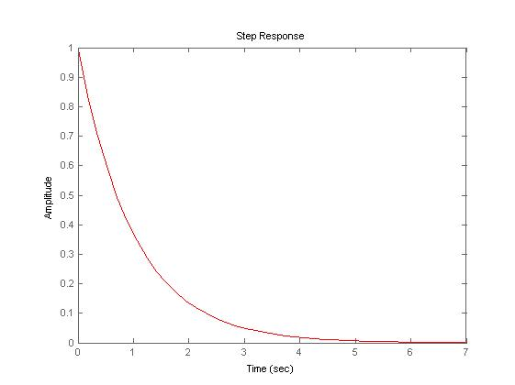

Actual system with observer graph

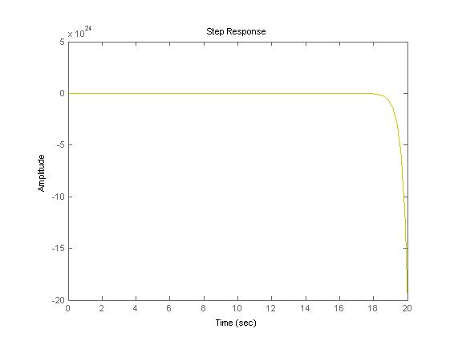

Q2 Consider a self driving car. This car should be able to identify other cars around it in traffic.

What parameters will you measure to get information about neighboring cars?

Ans Distance,velocity,angle

Q3 How many variables will you measure?

Ans 3 if we consider 2d motion i.e distance,velocity,angle(seeing from top view)

2 if we consider 1d motion i.e distance,velocity

Q4 How many variables do you need to know in order to predict where the neighboring car will be in the next instant?

3 variables distance,velocity,angle